Mother’s Day Stories

Books for Preschoolers:
Fox, Mem. Harriet You’ll Drive Me Wild! E Fic
Guarino, Deborah. Is Your Mama a Llama? E Fic
Joose, Barbara. Mama, Do You Love Me? E Fic
Rockwell, Anne F. Mother’s Day E Fic
Wood, Douglas. What Moms Can’t Do E Fic

Book for School Agers:
Mommy Poems E 811.008 Mom
Flack, Marjorie Ask Mr. Bear E Fic You can act this story out with animal puppets or flannel pieces
Munsch, Robert Love You Forever E Fic
Zolotow, Charlotte Mr. Rabbit and the Lovely Present E Fic You can act the story out with a rabbit puppet, plastic or paper fruit and a basket

Flannel: “Five Little Ducks”

Mother’s Day Song: “I’m Bringing Home a Baby Bumblebee”

http://www.dltk-kids.com/t_template.asp?t=http://www.dltk-teach.com/rhymes/bumblebee/bbaby-bumblebee.gif
Mother’s Day Crafts
http://www.dltk-holidays.com/mom/index.html
Mother’s Day Tea Ideas
http://www.thevirtualvine.com/MothersDay.html

Submitted by:
Charmette Kendrick
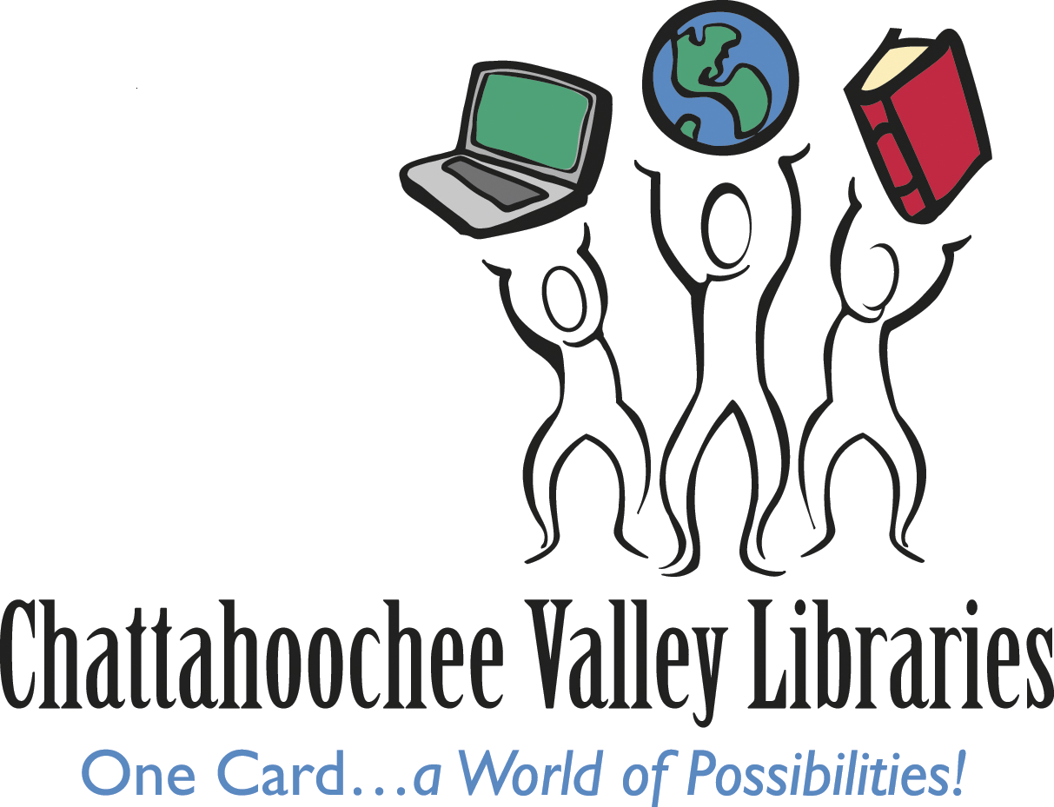
ckendrick-kuhn@cvrls.net
Children’s Librarian
South Columbus Public Library
2034 South Lumpkin Road
Columbus, GA 31903
Chattahoochee Valley Libraries
www.thecolumbuslibrary.org

